The British Section
Parent Staff Association
SHAPE International School
SHAPE
BFPO 26

Tel: 0032 (65) 445283
Email: shape.admin@modschools.org
Website: www.britishsectionshape.com

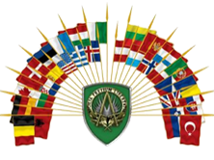
International, Inspiring, Incredible

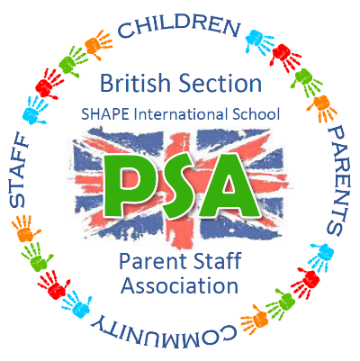

PSA Event Planning Table

Month | Events / Activity | Remarks | Lead  Co-ordinator | Money Awarded to
2020
Feb | 17 to 19 Feb - Preloved Uniform sale | Volunteers required to assist with this sale. | DW | PSA Fund
 | Community Quiz |  | CLO
Mar | Red Nose Day |  | School | Charity
 | 20 Mar - International Day |  | School
 | Community Bingo |  | CLO
Apr | 3 Apr – No School Uniform Day & Cup Cake Design Competition | a. Request for a small donation for mufti.  b. All Cup Cakes will be nut free, the categories and Judges will be chosen nearer the time by Chair.  c. All prizes donated by the PSA. | DW | PSA Fund
 | Community Quiz |  | CLO
May | Community Bingo |  | CLO
 | 21 May - Make A Wish |  |  | Charity
Jun | 6 Jun - Brit Fete  (Book Sale, Pimms & Water stall) |  | DW & CJ | PSA Fund
 | Community Quiz |  | CLO
 | School Disco (date TBC) |  | SH | PSA Fund
 | 30 Jun - ‘Thank you’ to the school – picnic lunch, popcorn, candyfloss, ice cream etc |  | DW | PSA ‘Payback’ to say thank you to the pupils and Teachers of the School
SCHOOL CLOSED
Aug | Welcome to new Parents | For further discussion at the next meeting - Apr 20. | All
 | Community Quiz |  | CLO
Sept | 4 to 5 Sep – SHAPE FEST | Face Painting stall (?) | TA (?) | PSA Fund
Oct | Poppy Appeal |  | School | Charity
Nov | Pudsey’s Got Talent |  | School | Charity
Dec | GBR Christmas Market (book sale) | No Lead allocated as yet. | ???? | PSA Fund
 | Christmas Production – if held at the School  (inc Gluhwein & other beverages) | No Lead allocated as yet. | ???? | PSA Fund
 | School Disco |  | SH | PSA Fund

Discussed but discounted at this time: Christmas boxes for local Charities
Year Book
Leavers BBQ
Bingo and/ or Quiz
Scavenger Hunt
Make a Wish (2021)

. Where the event is coloured orange it is for information only.
. Where the event is in Italics it is not a PSA organised or PSA benefited event.

